**11.1.1**

This is a bad idea. Can we call Mrs Berry.

It's far. I can fix the light bulb.It's jack one light bulb. oOh.

You're Okay?

Yah. I'm Okay.How are you?

I'm Okay. But fear The TV is Okay. No

We can buy new things.

You're right.We can buy new things.Let's go shopping.

Okay.

Shen. You don't need a shoes and a jacket to go shopping.

We have to go to stores to buy new things. The electronic store for a TV. The clothing store for a shirt. The furniture store for a table and a chair.

We don't have to go out the apartment to buy a TV, shirts or anything.

We wrong.

No. The road here. we go to the Nile warehouse.com .It's an online store that is all of those stores in one store. Come here.

Look at this .It's an electronic store.it's a clothing store.

Wow

And It's a furniture store.

And It's a book store.This is a great website.

The furniture store on Main Street has lots of nice things. Let’s go there!

I need to go to the bookstore. Do you want to come?

There’s a new shoe store on First Avenue. Let’s go there tomorrow.

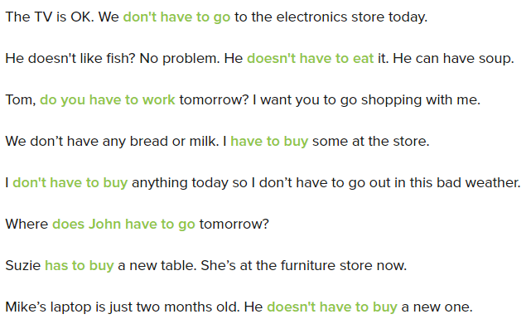

I have to buy some things. Do you want to go shopping with me?

Yes, I don’t have to work today. Let’s go shopping!

I have to buy a new phone.

OK, we can go to the electronic store.

Good. And I need new shoes, too.

I have to buy shoes, too. We can go to the shoes store.

And I need to go to the bookstore.

Oh, good! I have to buy the book for my friend Sasha. It’s her birthday next week.

And I need a small table for my bedroom. so

I know. We have to go the furniture store.

Benny and Shen need a TV. They have to go to the electronics store.

I like our old table and chairs. We don’t have to buy new furniture.

I really need a new shirt. Let’s go to a clothing store.

People can shop online with a cell phone. They don’t have to use a computer.

This online store has sofas and tables, jackets, books, TVs and phones … anything!

The weather is bad, but I have to do to work. We have a meeting with the boss today.

A: Let’s go to a clothing store.

B: Great! I need a jacket.

You need lots of things, Ed! A person has to have lots of time to go shopping with you!

**11.1.2**

Okay. Let’s buy the things we need. **Frist, a coffee table**

**That’s an organge table**

Yes. It is. But I don’t want an organge table, **I want a black table**

**That’s a good table**

**It’s an excellent table**

How much does it cost?

I don’t know. But I like it. Buy

**Now. We need a TV**. Isn’t that an expensive TV?

I don’t know. But I like it. Buy

We need two plates and a cup

Is this a good cup?

No. That is an _ cup

Yes. It’s a good cup. Buy

**I need a shirt**

**That’s excellent shirt**

It’s an ugly shirt. I want a good shirt. This is a cool shirt

How much is it cost?

20$

20$? That’s expensive

No. That’s cheap and I need a shirt

Sorry Shen. No shirt

Yes. I need a shirt

Time to buy these things

The buy clothes online

Shen and Benny do not buy a jacket

Benny says the cool shirt is expensive

Shen buy the shirt

He lives in an apartment

Bring me a knife, please

James is an actor

I’d like an apple

She is an engineer

That is not a bookstore

I’ve got an umbrella

Take a picture, please

Aida is a singer. She loves music

This is Andrew. He work in an electronics store

My friend thomas doesn’t have a job. He needs money

Maria is from Italy. She is a student at the university

Andre is a designer. He designs clothes in New York

Sam is a greate cook. She loves food.